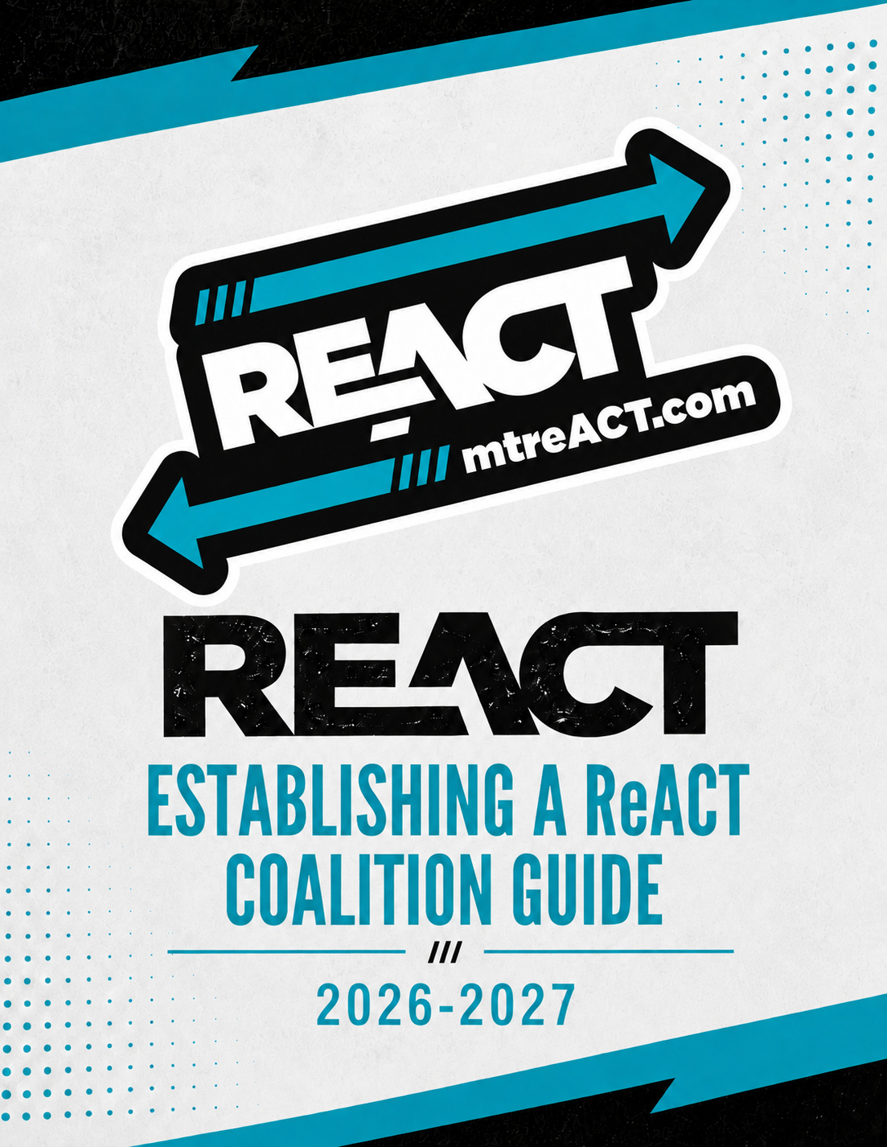

Steps for Establishing a ReACT Coalition
County: |  | School: |  | School Year:
Organizer: |  |  |  | Date:
Step 1: Research ReACT Program
Research the ReACT program and identify if the program work could help meet a need for youth in your community. List at least three needs of youth in your community that could be addressed by the formation of a ReACT coalition.
Step 2: Evaluate Youth & Educators Interest
Do youth and educators in my community have an interest in participating in the ReACT program after hearing about it during educational presentations by the local Tobacco Education Specialist? In the box below list what evaluation tool was used to gather audience feedback and the results. If the outcomes are favorable to establish a ReACT coalition continue to the next box.
Step 3: Identify & Confirm an Adult Advisor
Contact a minimum of two educators to meet in person (e.g., teachers, counselors, youth ministers, etc.) to inquire if they would be interested in running a ReACT coalition for one year with the option to renew for a second year. During the meeting, review the requirements of a reACT coalition advisor (e.g., refer to the ReACT Guide at www.mtreact.com). In the space below work with the advisor to complete the following tasks.
• Review all resources for ReACT adult advisors.
• Review the ReACT 2026-27 Events Calendar.
• Review the ReACT website.
• Follow ReACT social media.
• Schedule a training call with the ReACT Program Director.
Step 4: Planning Meeting with Adult Advisor
Set up a follow-up meeting to begin planning the coalition’s yearly calendar. In the space below, work with the advisor to complete the following tasks.
• Take the tobacco-free online pledge.
• Select a meeting day, time, and place (e.g., weekly, or bi-weekly.)
• Identify potential members based on the youth feedback from step 2.
• Schedule a recruitment table during the first month of school during lunch to sign youth up to attend the first meeting on (enter meeting date here.)
• Create media advertisements for the coalition to be displayed around the school for two weeks before the first meeting.
• Plan a kickoff week for the coalition with fun activities such as pairing it with a day of action like Red Ribbon Week.
• Prepare coalition meeting agendas.
• Print all ReACT state event flyers to distribute to youth and advertise throughout the year
Step 5: Recruiting Youth
Meet with the ReACT Adult Advisor to generate a list of potential youth members who showed interest back in step 2 during the presentation evaluation.
• Create personal invites for each identified student from the evaluations and deliver them personally or in their lockers.
• Work with the school administration to host a recruitment table at lunch or after school to invite youth to join the coalition’s first meeting. The goal of recruiting at this stage is to get as many students as possible to the meeting and then ask them to join the coalition. After the first meeting ask the students to sign the ReACT tobacco-free pledge and register on the ReACT website (e.g., www.mtreact.com).
Step 6: ReACT Coalition Retention
After a successful first meeting, please maintain your coalition.
• A minimum of two youth
• One adult advisor
• Participate in at least four ReACT statewide events yearly.
• Complete required training courses: Take Down Tobacco refer to ReACT Program Guide for course name and link.

