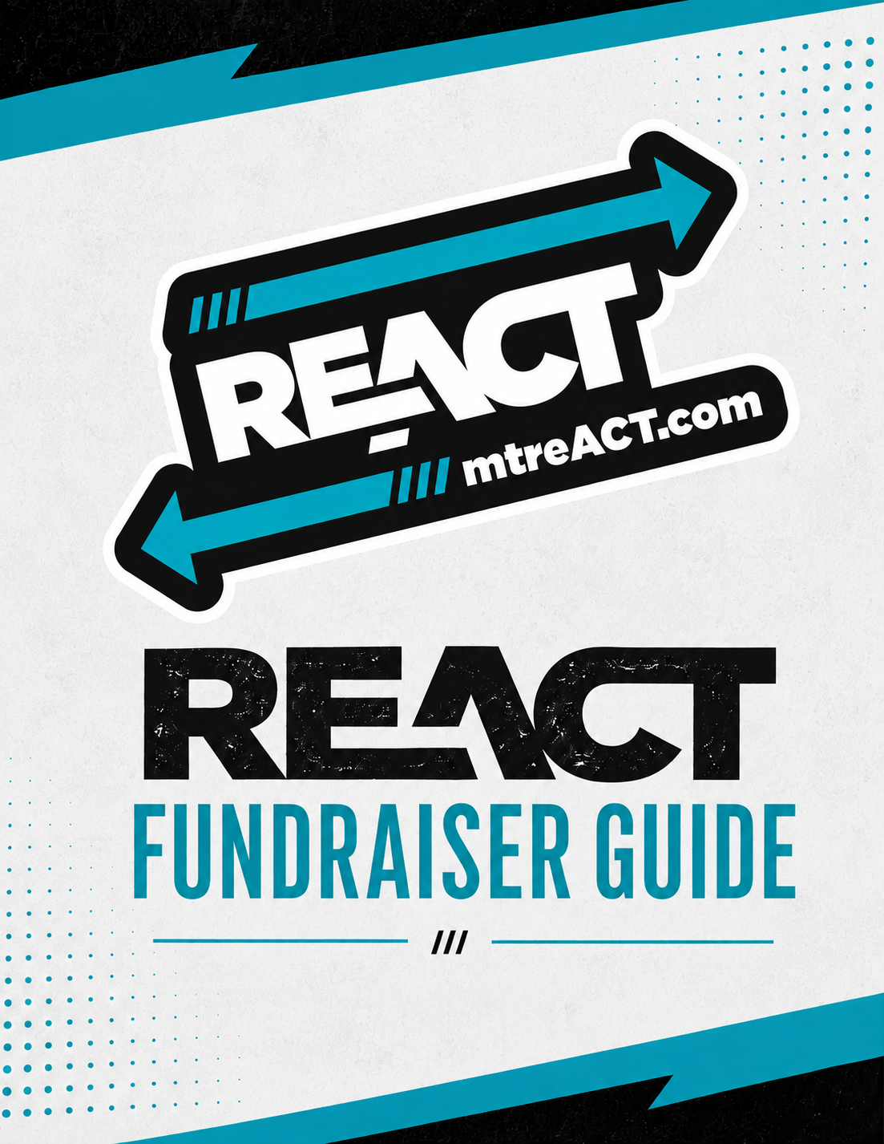
Table of Contents

Introduction 2
Fundraising Tool: The Funnel 3
Fundraiser Steps 4
ReACT Fundraisers 5
In Person Fundraisers 6
Virtual Fundraisers 7
Citations 8

Introduction
This guide will help youth and advisors develop fundraisers for their ReACT coalition(s) or other youth prevention programs. Fundraising is the process of seeking and gathering voluntary financial contributions by engaging individuals, businesses, charitable foundations, or governmental agencies.
Traditionally, fundraising has consisted mainly of asking for donations through face-to-face fundraisings, such as door-knocking. In recent years, though, new forums such as online fundraising have expanded their reach from city to county to statewide events. This guide will highlight both fundraising techniques in person and virtual for a combined approach to increase your range of potential donors.
If you have any questions or concerns, please contact the ReACT Program Director.

Fundraising Tool: The Funnel
Prospecting
Identify people, businesses, or organizations in your community who may be interested in supporting your fundraiser or ReACT's mission.
Cultivation
Build relationships with potential supporters by communicating with them and helping them understand what your coalition is doing.
Asking
Invite people, businesses, or organizations to support your fundraiser. Be clear about what you are asking for and how their support will help your coalition.
Stewardship
Thank your supporters and continue building those relationships after the fundraiser. Continue to build the relationship with the donors through communication until the next time you are asking for their support.

Fundraising relationships can continue over time and is a cyclical process.
Find → Build → Ask → Thank → Build again

Fundraiser Steps
Step 1: Build Your Team
- Select a Youth Lead
- Select an Adult Advisor
- Select Team Members
Step 2: Choose Your Fundraiser
- Choose a fundraiser that fits your coalition, community, goals, and available resources
- Need an idea? Check out the ReACT Activity and Ideas Library for fundraiser ideas and ready to use plans
Step 3: Set Your Goals
- ReACT Program Awareness
- Monetary donations
- Education
- Advocacy
- Action
Step 4: Create a Budget
- Create a list of materials needed, including venue, food, prizes, swag, and activity supplies.
Step 5: Promote Fundraiser
- Let your community know about your fundraiser. Consider using:
  - Social media posts or stories
  - Videos
  - Flyers
  - Newspaper articles
  - Community or school displays
  - Other appropriate community outreach
Step 6: Launch Fundraiser
- Make sure your team has confirmed the date, time, location, and team responsibilities
Step 7: Review Your Results
- Afterwards, collect feedback from participants and review results as a team.

ReACT Fundraisers
ReACT has developed several fundraiser ideas that coalitions can use or adapt to fit their community. Each fundraiser has a separate planning sheet with additional guidance.
ReACT Cook-Off
- During the spring, ReACTors may host a community chili cookoff. Invite community members to select their favorite chili and learn how they can participate in a spring day of action such as Through with Chew, Take Down Tobacco Day, and or World No Tobacco Day.
- Click here to learn more about a Chili Cook Off.
ReACT Pet Pageant
- During the spring & summer seasons, ReACTors may host a community-wide pet pageant at the local high school gym or the town square. Bring community members together to celebrate their furry friends and learn about how secondhand smoke affects pets.
- Click here to learn more about hosting a community pet pageant
Holiday ReACTor
- During Christmas, ReACTors, as a coalition or individually, may provide services such as gift wrapping, hot chocolate stations at local winter festivals, childcare for holiday shopping, and events set up for community activities.
- Click here to learn more about the Holiday ReACTor
Looking for something different?
Explore the ReACT Advisor Activity & Ideas Library for additional fundraiser ideas and ready-to-use plans.

In Person Fundraisers
1. Dinner Feeds
- Recruit teens to organize a large dinner feed. Select an inexpensive meal such as spaghetti or chili.
- Hold it in a recreation center or school cafeteria and invite the community.
- Attendees pay a set fee to eat the meal.
- Sell tickets in advance.
- Ask teens to delegate who will cook, serve, bus tables, and take tickets to play.
2. Dial a Food Item
- Sell a food item for later delivery to nearby resident locations.
- Individuals will call to place their orders for delivery; the payment method can be cash or electronically via PayPal or Venmo.
- Advertise via social media and flyers around town for two weeks before the event.
3. Video Game Tournament
- Recruit teens and adults to compete in a video tournament to play for 6-12 hours.
- Pick a specific genre such as puzzle games or multi-player games such as Mario cart.
- Participants can either pay $10 to play or get community sponsors to donate $5 per hour played by all participants.
4. Wacky Car Wash
- Vehicles always need to be washed. Car washes are classic for good reason.
- Ask teen volunteers to dress up in crazy outfits or outfits with a theme, like superheroes or NFL teams.
- Teams can participate in shifts, competing to see which group can raise the most money, turn around the most cars, or have the best sidewalk hustle.
- Promote it in advance, and don’t forget creative signs to lure in customers on the fly.
- Offer a prize to the winning team such as a pizza party or gift cards to a local coffee shop.
5. Gift Wrapping
- Recruit teens to set up a gift-wrapping station around the holidays in return for a charitable donation.
- Teens can offer this service at a church or school or partner with local

Virtual Fundraisers
1. Learn a Skill Night
- Host a live stream event for students to teach skills such as juggling, painting, or popular dance routines.
- Create a social media post with an event hashtag.
- Invite participants to donate using: Venmo or Google Pay
- Use stream platforms such as Zoom, Facebook Live, or Google Hangouts.
2. How to Do Videos
- Create five-minute "How to Do Tutorials" on things like Zoom. Facetime, Target Pickup, Instagram, or Walmart Pickup.
- End each tutorial with a fifteen-second clip asking to promote the program and make donations via Venmo.
- Students can hold online classes so that participants can ask questions and learn in real time. Have an adult volunteer also participate in the study to help bridge any gaps.
3. Virtual 5k Walk or Run
- Use Google Forms to create an event registration system.
- Ask participants to pay their registration and choose their starting line (they can do the run on a treadmill, outdoors, indoor track, etc.).
- Runners race the distance specified (5K) or run a sweep of their choice and pay $5/mile.
After the event, invite participants to upload their finishing times through the Google Sheet. Tally up the times and let people know those stats!
- To view the event tutorial, click here.
4. Video Letter
- Video Letter is a creative take on the age-old support letter, but instead of sending out letters, the group contributes a video of reACTors in the program.
- ReACTors film themselves at home, reading their parts of the script.
- A tech-saavy student can then edit & post the video on social media platforms.

Citations
1. Chung, E. (2021, June 1). 44 Charity and Nonprofit Fundraising Event Ideas. Classy.org. https://www.classy.org/blog/fundraising-event-ideas-raise-moneycause/
2. Garecht, J. (2019, February 3). Non-Profit Basics: What is Fundraising?: GFA. Joe Garecht Fundraising. https://garecht.com/what-is-fundraising/
3. Raj, R. (2021, May 24). Ultimate List of 17 Fundraising Ideas for Teens in 2020. Donor Box Blog. https://donorbox.org/nonprofit-blog/fundraising-ideas-for-teens/
4. Colwin, D., & Franklin, D. (2020, November 17). Social Distance Fundraising: LeaderTreks Youth Ministry Blog. LeaderTreks Youth Ministry. https://www.leadertreks.org/social-distance-fundraising /

