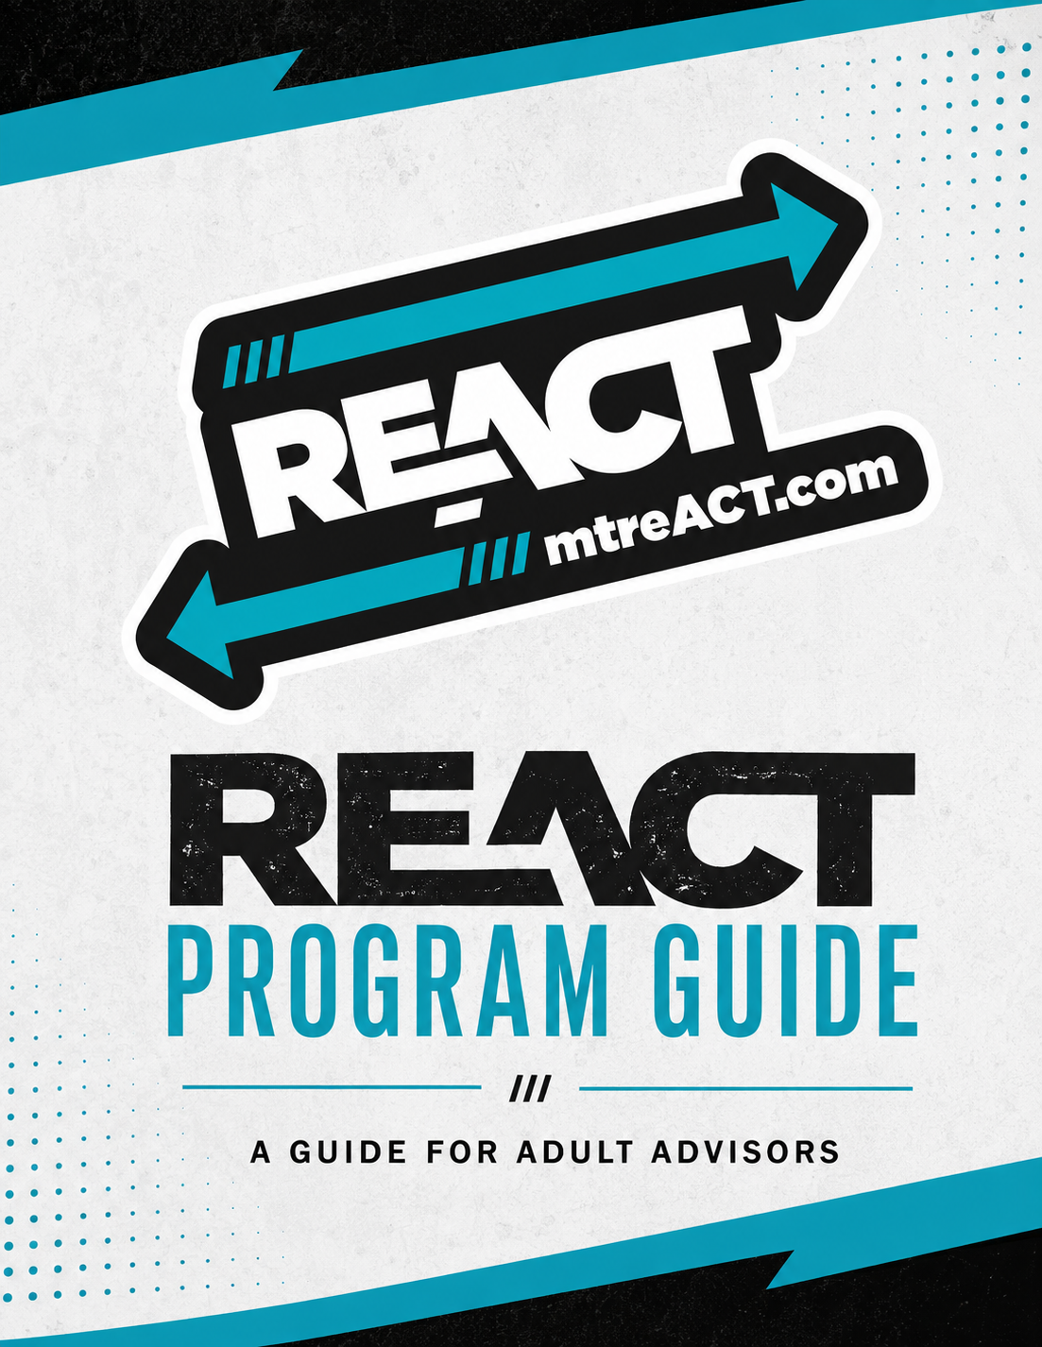
Table of Contents

Welcome to ReACT 3
Getting Started as an Adult Advisor 5
Building and Maintaining a ReACT Coalition 6
Annual ReACT Timeline 7
ReACT Coalition Stipends 8
Planning Coalition Activities 9
ReACT Activities & Opportunities 10
Education, Advocacy, and Action 11
Communication, Promotion, and Community Connections 12
Reporting and Evaluation 13
Youth Safety, Consent, and Participation 14
Additional Resources and Support 15

Welcome to ReACT

1.1 Welcome to ReACT
Welcome to ReACT! As an adult advisor, you play an important role in helping Montana youth build the knowledge, confidence, and leadership skills they need to make an impact in their schools and communities.

ReACT is Montana’s teen-led movement to reject commercial tobacco while upholding the sacredness of ceremonial tobacco..Through education, advocacy, and action, ReACTors work to become the first ever tobacco-free generation in Montana.

This guide is designed to provide adult advisors with the information and resources they need to support a successful ReACT coalition throughout the year. ReACT is youth-led and adult-supported. Your role is to provide guidance, resources, connections, and support while giving youth the space to lead.

1.2 ReACT’s Approach
Educate:
ReACTors provide current and relevant information on tobacco-related subjects. Examples may include but are not limited to the following:
- Known harms of commercial tobacco use
- E-cigarettes
- Marketing tactics of Big Tobacco
- Increase awareness of cessation programs such as My Life, My Quit
Advocate: ReACTors support legislation designed to protect Montana teens from the harmful products of Big Tobacco. Examples may include but are not limited to the following:
- Adoption of Tobacco-free School of Excellence policies for k-12th
- Adoption of Tobacco-free Campus policies at Montana institutions of higher education
- Adoption of legislative policies designed to protect Montana youth from tobacco products
Act: ReACTors work together to educate peers and adults on local and state activities. Examples may include but are not limited to the following:
- Promote the tobacco-free pledge
- Participate in days of action events
- Participate in state-wide summit
- Inform decision-makers on the known harms of tobacco use

1.3 What Does a Coalition Do?
ReACT coalitions bring youth together with the support of an adult advisor to take action on commercial tobacco and nicotine prevention in their schools and communities. Coalitions may:
- Educate peers and community members about commercial tobacco and nicotine
- Participate in ReACT activities, events, competitions, and days of action
- Plan local education and awareness activities
- Engage with community partners and decision-makers
- Advocate for tobacco-free policies and environments
- Participate in statewide ReACT opportunities.
Every coalition will look a little different. The goal is to give youth meaningful opportunities to Educate, Advocate, and Act in ways that fit within their schools and communities.

Getting Started as an Adult Advisor

2.1 Your Role as an Adult Advisor
Adult advisors provide the support, resources, and guidance needed to help youth lead a successful coalition. Advisors help youth plan activities, navigate logistics, connect with ReACT staff and community partners, and meet program requirements, while encouraging youth to take ownership of the coalition and its work.

2.2 Advisor Responsibilities
Adult advisors are responsible for:
- Supporting youth as they plan and lead coalition activities
- Helping the coalition set goals and plan for the school year
- Supporting regular coalition meetings and communication
- Providing youth with ReACT information, resources, and opportunities
- Helping youth connect with school, community, and ReACT partners
- Supporting participation in ReACT activities, events, competitions, and days of action
- Communicating with ReACT staff and local tobacco prevention partners.
- Helping the coalition complete required applications, reports, and other requirements
- Supporting safe and appropriate youth participation in coalition activities

2.3 Advisor Requirements
Adult advisors must:
- Be 18 years of age or older
- Complete ReACT advisor orientation and onboarding
- Commit to serving as the adult advisor for the full school year
- Attend ALL quarterly ReACT advisor calls
- Complete a makeup 1:1 meeting with the Program Director if a quarterly call is missed
- Maintain communication with Program Director
- Complete required reporting
- Help coalition remain in good standing
- Complete ongoing training determined by the Program Director

2.4 Advisor Application & Approval
Individuals interested in serving as a ReACT Adult Advisor must complete the ReACT Advisor Application and participate in an approval process with ReACT staff. The application and approval process helps ensure that advisors understand the ReACT program, are able to fulfill the responsibilities of the role, and are a good fit to support a youth-led coalition. Completion of an application does not guarantee approval to serve as a ReACT Adult Advisor. ReACT staff will review applications and determine advisor approval.

Once approved, Adult Advisors must complete ReACT Advisor Orientation and the six required Take Down Tobacco Training Program courses.

Building and Maintaining a ReACT Coalition

3.1 What is a ReACT Coalition?
A ReACT coalition is a group of youth participating in ReACT activities and opportunities with the support of an adult advisor. They help educate, advocate, and act to impact their schools and communities, working to become the first ever tobacco free generation in Montana. Coalitions may be school or community based, and can look different from one community to another.
ReACT is designed to give youth meaningful opportunities to lead. They should have a voice in choosing activities, setting goals, making decisions, and taking action within their coalition. The advisor’s role is not to do the work for the youth, but to create the structure and support they need to lead.

3.2 Getting a Coalition Started
When starting a coalition:
- Identify an adult advisor and interested youth
- Register the coalition through the ReACT website
- Complete the required advisor orientation with the ReACT Program Director
- Establish regular coalition meetings and a way to communicate with coalition members
- Identify goals and activities that give youth opportunities to educate, advocate, and act

3.3 Youth Participation
ReACT is designed to give youth meaningful opportunities to participate, lead, and take action. They may participate through coalition meetings, ReACT activities and events, days of action, competitions, education and awareness activities, community engagement, and other ReACT opportunities.
Adult advisors should work with the youth coalition members to identify opportunities that fit their interests, goals, and community. Youth should have the opportunity to help choose activities, take on responsibilities, and contribute to the decisions within the coalition.
Active youth: For the purpose of coalition stipend funding, active youth is defined as a student who is registered with the coalition and participates in a minimum of three coalition meetings, activities, events, or other ReACT opportunities throughout the school year.

3.4 Maintaining an Active Coalition & in Good Standing
A successful ReACT coalition stays engaged throughout the school year. A coalition is considered to be in good standing when it:

Maintains an active ReACT coalition:
- Has an adult advisor
- Has active youth
- Operates as a ReACT coalition throughout the school year
Meets ReACT participation requirements:
- Participates in ReACT activities, events, days of action, and/or competitions
- Engages youth in ReACT education, advocacy, and action
- Participates in ReACT opportunities such as the Summit, presentations, and meetings with decision makers, as appropriate
Meets advisor requirements:
- Advisor completes required ReACT orientation
- Advisor attends all quarterly advisor calls
- If an advisor misses a call, they complete the required 1:1 make up call with the Program Director
- Advisor maintains communication with the Program Director
Completes required reporting:
- Mid-year progress report is submitted no later than February 1st
- End of year report is submitted no later than June 30th
Uses stipend funds appropriately:
- Funds are used for approved ReACT expenses
- Funds are not used for lobbying expenses

Annual ReACT Timeline
October 1: Stipend Application Deadline
October (last week): Red Ribbon Week
November 19: Great American Smokeout
February 1: Mid-Year Progress Report Deadline
February: Take Down Tobacco Sticker Design Competition
February 18: Great American Spit Out
April 1: Take Down Tobacco Day
April: Celebration on the Hill
May 31: World No Tobacco Day
June: ReACT Summer Summit
June 30: End of Year Reporting Deadline

Important: ReACT event dates and deadlines are shared throughout the year. Check communications from the ReACT Program Director and the ReACT website for current opportunities.

ReACT Coalition Stipends

5.1 Coalition Stipends

The purpose of these stipends is to support ReACT coalitions with costs associated with participation and activities throughout the year. Allowable expenses may include adult advisor stipend, meeting materials, event expenses, gear items, and youth speaker stipends.

Funding is based on the number of active youth in the coalition and is distributed during two funding periods during the school year. Please see the ReACT Coalition Stipend Information Sheet for current funding amounts, application deadlines, eligibility requirements, and distribution details.

5.2 Spending Guidelines

ReACT coalition stipend funds may be used for expenses that support coalition participation and activities, including:
- Adult Advisor Stipend
- Meeting Materials
- Event Expenses
- ReACT Gear Items
- Youth Speaker Stipends
ReACT stipend funds may not be used for:
- Political activities: Supporting or opposing a political candidate, political party/committee, ballot issue, or legislation.
- Lobbying: Using funds for lobbying or activities intended to influence legislation.
- Tobacco industry involvement: Partnering with, receiving funding from, or participating in activities or events sponsored by the tobacco industry or a tobacco-industry subsidiary.
- Nicotine replacement products or medications: Purchasing nicotine gum, patches, or prescription medications used to treat nicotine dependence.
- Cessation programs: Paying for individual tobacco cessation classes or similar individual behavior-change activities.
- Surveillance or punitive measures — Purchasing vape detectors, drug tests, drug dogs, cameras, or other surveillance tools that could result in punitive action against someone who uses nicotine or vaping products.
- Paying people to quit tobacco: Providing payment or other funds to tobacco users as an incentive to quit.
- Cash incentives for participation: Giving cash incentives to youth or community members for participating in a ReACT coalition or coalition activity.

Are you unsure about whether an expense is allowable or not?
- Do not purchase it yet
- Review the spending guidelines
- If you are still unsure, contact the ReACT Program Director before spending the funds
- Be prepared to share what you want to purchase and how it will support your ReACT coalition or activities
- Wait for guidance before making the purchase

Coalitions are responsible for maintaining receipts and other documentation supporting stipend expenditures. ReACT may request documentation at any time. A summary of stipend expenditures will be included in the end-of-year report.

Planning Coalition Activities

6.1 Plan With a Purpose
Before planning an activity, work with the active youth members to decide what the coalition wants to accomplish. A strong activity has a clear goal, a defined audience, and a plan for how the activity will support the goal.
The 5 W’s
WHY are you doing the activity? What do you want to accomplish?
WHO is your target audience?
WHAT activity will help you reach your goal?
WHERE will you hold the activity?
WHEN should the activity take place?

6.2 Before the Activity
Work with youth to:
- Assign responsibilities and deadlines
- Identify needed materials and resources
- Complete any required permission or consent forms
- Promote the activity
- Coordinate with partners or community members
- Develop a clear call to action when appropriate

6.3 After the Activity
- Discuss what went well and what could be improved
- Follow up on the activity’s goal or call to action
- Thank partners, volunteers, and participants
- Share appropriate photos, outcomes, and accomplishments with ReACT’s Program Director
- Share appropriate photos, outcomes, and accomplishments on ReACT’s and your own social media pages

ReACT Activities & Opportunities
ReACT offers opportunities throughout the year for youth to learn, lead, educate others, and take action. Coalitions are encouraged to participate in activities that fit their interests and goals.

7.1 Statewide Opportunities
Take Down Tobacco Day
Take Down Tobacco Sticker Design Competition
ReACT Summer Summit
Celebration on the Hill
Days of Action

7.2 Local Opportunities
Coalitions are encouraged to create their own activities that respond to the specific needs and interests of their school and community. Activities may include things like peer education, community events, presentations, awareness campaigns, meeting with local decision makers, and other youth led campaigns.
Advisors are encouraged to utilize the Advisor Activity and Ideas Library when they need inspiration for the local opportunities. Advisors are also encouraged to submit their successful activities to the Program Director to be added to the Library for other coalitions to use as inspiration as well. If you need help with any part from start to finish in holding local activities and opportunities, please contact the Program Director. They are here as a resource to use!

7.3 Staying Up to Date
ReACT opportunities, dates, and registration information are shared throughout the year. Advisors should monitor communication from the Program Director, ReACT social media channels, and the website for current opportunities and deadlines.
Facebook: www.facebook.com/react.montana.1
Instagram: https://www.instagram.com/mtreact/
TikTok: https://www.tiktok.com/@montanareact
Website: www.mtreact.com

Education, Advocacy, and Action

8.1 Educate
ReACTors can educate their peers, schools, and communities about commercial tobacco and nicotine. Activities could include:
- Sharing information about the known harms of commercial tobacco use
- Educating others about e-cigarettes
- Teaching others about the marketing tactics used by the commercial tobacco industry
- Increasing awareness of cessation programs such as My Life, My Quit
- Giving e-cigarette presentations

8.2 Advocate
ReACTors can advocate for policies and environments designed to protect Montana youth from commercial tobacco. Examples may include:
- Supporting tobacco-free school policies
- Supporting tobacco-free campus policies at Montana institutions of higher education
- Supporting legislative policies designed to protect Montana youth from commercial tobacco products
- Meeting with decision makers to share the harms of commercial tobacco use

8.3 Act
ReACTors put their knowledge into action through activities and events. Examples include:
- Promoting the tobacco free pledge
- Participating in Days of Action
- Participating in ReACT’s Summer Summit
- Participating in the Take Down Tobacco Sticker Design Competition
- Participating in Celebration on the Hill
- Informing decision makers about the known harms of commercial tobacco use

8.4 Advocacy vs. Lobbying
ReACT encourages youth advocacy, but stipend funds cannot be used for lobbying-related activities. Click here for a webinar and here for the CADCA Toolkit for more information.
- Advocacy includes educating others, raising awareness, and supporting policies designed to protect youth from commercial tobacco.
Lobbying is a specific type of advocacy that involves attempting to influence legislation or a specific legislative action.

Communication, Promotion, and Community Connections

9.1 Communication
Advisors play an important role keeping their coalition connected to ReACT and their community. Advisors should maintain regular communication with the ReACT Program Director, share program updates and opportunities with youth, and help the coalition stay informed about upcoming activities and opportunities.

9.2 Promoting Your Coalition
ReACT encourages coalitions to share their work and opportunities with their peers and community. Coalitions may use social media, community events, and other appropriate outreach opportunities to recruit youth and promote ReACT activities.
When promoting ReACT, use current ReACT messaging and branding to help maintain a consistent identity across the state.

9.3 Community Connections
ReACT coalitions are encouraged to connect with their schools and community. Adult advisors can help youth identify appropriate community partners, opportunities for education and engagement, and connections with the local Tobacco Education Specialist and other community contacts.
Building these connections can help the coalition expand their reach of work and find more opportunities to educate, advocate, and act.

Reporting and Evaluation

10.1 Mid-Year Report
Due February 1st
The mid-year report provides an opportunity to:
- Document coalition activities and youth engagement
- Update the coalition’s active youth count
- Report on stipend use
- Identify plans and needs for the remainder of the school year

10.2 End-of-Year Report
Due June 30th
The end-of-year report documents:
- Coalition accomplishments and activities
- Youth and community engagement
- Stipend use
- Overall program outcome and reflections for the school year
10.3 What Advisors Should Track
Throughout the year advisors should track coalition activities, youth participation, accomplishments, and stipend expenditures. Keeping simple records throughout the year will make completing required reports easier.

Youth Safety, Consent, and Participation

11.1 Youth Accountability
- Respect and Dignity
- Confidentiality of information shared during ReACT activities
- Follow through on tasks through completion
- Attending events youth are registered for and selected to attend
- Addressing attendance or participation barriers on a case by case basis with youth, parent/guardian, and the youth leader

11.2 Consent and Media
- Parent/guardian consent is required for youth to participate in ReACT activities
- Consent covers participation for in person and virtual events and ReACT social media campaigns
- Consent addresses the use of photographs, testimonials, suggestions, comments, and other information for ReACT promotional purposes

11.3 Travel and Events
- Advisors should ensure that required consent/permission forms are completed for activities and events
- The ReACT consent form addresses potential risks associated with travel , including winter road conditions

11.4 Privacy
- Advisors and youth should protect personal information shared through ReACT activities
- Advisors should visit the ReACT Privacy Policy for information on how personal information is collected and used

11.5 Advisor Responsibility
- Advisors support and oversee coalition activities and youth participation
- Advisors should follow current ReACT requirements and use appropriate ReACT forms and resources when planning activities

Additional Resources and Support
ReACT provides advisors with additional tools and resources to support coalition development, youth leadership, activity planning, fundraising, and participation. Advisors should use the most current versions of these resources throughout the year. These resources can be found through the ReACT website.
The Advisor Activity & Ideas Library provides a growing collection of activity ideas and ready to use plans submitted by ReACT advisors and coalitions. We also have Base Camp, where you can find resources to use as you wish.Advisors with questions or who need additional support should contact the ReACT Program Director.
Find multiple hyperlinked resources below for youth engagement tools and programs. Each box includes the resource category and link to the website or digital file.
Organization | Website
ReACT | http://www.mtreact.com/
TRUTH Initiative Campaign | https://truthinitiative.org/
TobaccoFree Kids | https://www.tobaccofreekids.org/
MTUPP | https://dphhs.mt.gov/publichealth/mtupp/
Montana OPI | https://opi.mt.gov/
CDC | https://www.cdc.gov/
NIH | https://www.nih.gov/
My Life, My Quit | mylifemyquit.com/en-us/
This Is Quitting | https://truthinitiative.org/thisisquitting
ACTS For Youth | http://actforyouth.net/youth_development/engagement/
ISTEP Iowa | https://www.iowastep.org/
Resist Kansas | https://www.resisttobacco.org/
The 84 Mass. | https://www.the84.org/
Uprise Colorado | https://upriseyouthmovement.org/
American Lung Association | https://www.lung.org/
American Cancer Society | https://www.cancer.org/

